**Name: Nafinur Leo**

**Id: 20-42195-1**

**Course Name: Data Communication**

**Section: D**

**Lab Assignment: 01**

**Semester: 2021-2022 Fall**

**Submission Date: 19-10-2021**

ID = AB-CDEFG-H

Here, my id is: 20-42195-1

A = 2, B = 0, C = 4, D = 2, E = 1, F = 9, G = 5, H = 1

a1 = G+2 = 5+2 = 7

a2 = G+6 = 5+6 = 11

a3 = G+4 = 5+4 = 9

a4 = G+8 = 5+8 = 13

f1 = G+5 = 5+5 = 10

f2 = G+3 = 5+3 = 8

f3 = G+9 = 5+9 = 14

f4 = G+7 = 5+7 = 12

L = 8

sig_st = a1*sin(2*pi*f1*t)

sig_ct = a1*sin(2*pi*f1*t) + a2*cos(2*pi*f2*t) + a3*cos(2*pi*f3*t) + a4*sin(2*pi*f4*t)

1.Generating a simple signal and a composite signal in time domain and applying frequency analysis:

Code:

clc

close all

A=2;

B=0;

C=4;

D=2;

E=1;

F=9;

G=5;

H=1;

a1 = G+2;

a2 = G+6;

a3 = G+4;

a4 = G+8;

f1 = G+5;

f2 = G+3;

f3 = G+9;

f4 = G+7;

fs=20e3;

t=0:.001/fs:1;

sig_st = a1*sin(2*pi*f1*t);

sig_ct = a1*sin(2*pi*f1*t) + a2*cos(2*pi*f2*t) + a3*cos(2*pi*f3*t) + a4*sin(2*pi*f4*t);

nx = length(t);

plot(t,sig_st,'b','LineWidth',1.5);

xlabel('time');

ylabel('amplitude');

title('Simple Signal');

legend('Signal sig_st');

figure;

plot(t,sig_ct,'b','LineWidth',1.5);

xlabel('time');

ylabel('amplitude');

title('Composite Signal');

legend('Signal sig_ct');

fftsig_st = fft(sig_st);

fftsig_ct = fft(sig_ct);

fftsig_st = fftshift(fftsig_st)/(nx/2);

fftsig_ct = fftshift(fftsig_ct)/(nx/2);

f = linspace(-fs/2,fs/2,nx);

figure;

subplot(3,1,1);

plot(t,sig_st,'b','LineWidth',1.5);

xlabel('time');

ylabel('amplitude');

title('Simple Signal');

legend('Signal sig_ct');

subplot(3,1,2);

plot(f, abs(fftsig_st),'Linewidth',1.5);

title('Frequency analysis');

xlabel('frequency (hz)');

ylabel('amplitude');

xlim([-10 10])

axis([-0.1 0.1 0 10]);

figure;

subplot(3,1,1);

plot(t,sig_ct,'b','LineWidth',1.5);

xlabel('time');

ylabel('amplitude');

title('Composite Signal');

legend('Signal sig_ct');

subplot(3,1,2);

plot(f, abs(fftsig_ct),'Linewidth',1.5);

title('Frequency analysis');

xlabel('frequency (hz)');

ylabel('amplitude');

xlim([-10 10])

axis([-0.1 0.1 0 10]);

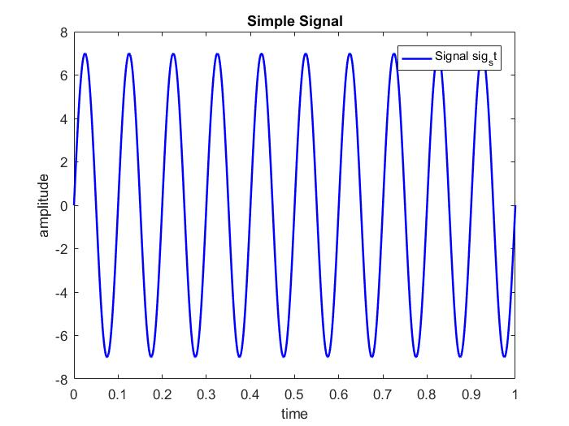

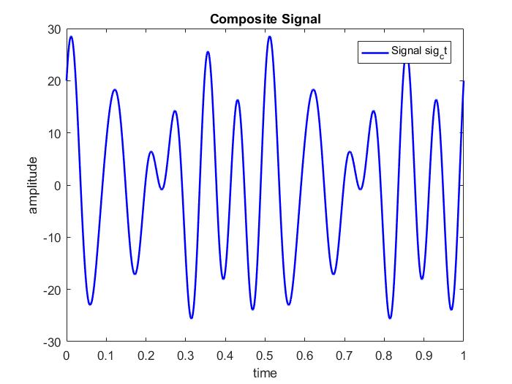

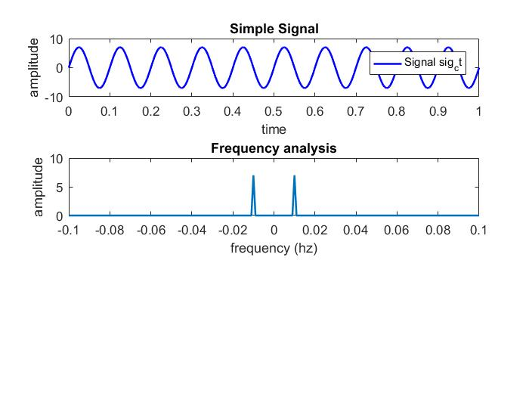

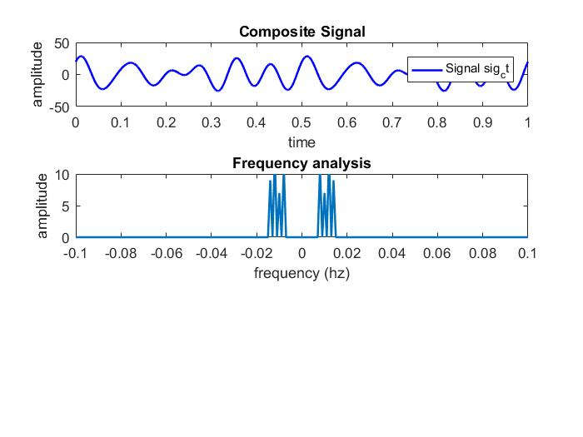

2.Uniform quantization on sig_ct:

Code:

clc

close all

A=2;

B=0;

C=4;

D=2;

E=1;

F=9;

G=5;

H=1;

a1 = G+2;

a2 = G+6;

a3 = G+4;

a4 = G+8;

f1 = G+5;

f2 = G+3;

f3 = G+9;

f4 = G+7;

f=240;

fs=20e3;

t = 0:1/fs:30/f;

L = 8;

sig_ct = a1*sin(2*pi*f1*t) + a2*cos(2*pi*f2*t) + a3*cos(2*pi*f3*t) + a4*sin(2*pi*f4*t);

delta=(max(sig_ct)-min(sig_ct))/(L-1);

xq = min(sig_ct)+(round((sig_ct-min(sig_ct))/delta)).*delta;

plot(t,sig_ct,'b *');

hold on;

plot(t,xq,'r x');

xlabel('time')

ylabel('amplitude')

title('Quantization Method')

legend('Original Signal','Quantized signal')

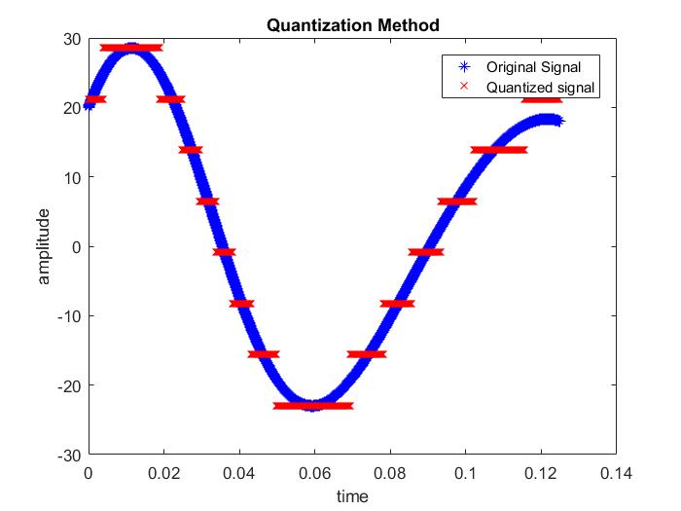

**Discussion:**

There is some of the bugs concluded with the definite organizational complementation with the functions of the MATLAB. The regression of the functions originated from the libraries inclines the comprehensive objective of this complementation. I face some problems while creating the plot and also face problems while calculation using my student id number. MATLAB takes some time while I try to run because my laptop configuration is low.